# MEGHNAD SAHA INSTITUTE OF TECHNOLOGY

*Nazirabad, P.O. - Uchhepota, Near URBANA Complex, Anandapur, Kolkata 700 150*

**BACHELOR OF COMPUTER APPLICATION**



LABORATORY NOTE BOOK

MAKAUT ODD SEMESTER 2023

PAPER NAME: COMPUTER NETWORKING LAB

PAPER CODE: BCAC592

STUDENT NAME: RUPAK SARKAR

ROLL NO: 31001221010

REGN. NO.: 213101001210001

YEAR: 3RD

SEMESTER: 5TH

SECTION: BCA

SESSION: 2021-2024



MEGHNAD SAHA INSTITUTE OF TECHNOLOGY

*Nazirabad, P.O. - Uchhepota, Near URBANA Complex, Anandapur, Kolkata 700 150*

## “LIST OF ASSIGNMENT/EXPERIMENT SUBMISSION DETAILS”

|  |  |  |  |  |  |
| --- | --- | --- | --- | --- | --- |
| **SL.**  **NO.** | **ASSIGNMENT / EXPERIMENT NAME** | **DATE OF ASSIGNMENT**  **/ EXPERIMENT DONE** | **DATE OF SUBMISSION** | **CHECKED BY** | **REMARKS**  **(ANY DEVIATION REGARDING SUBMISSION DATES, CONTENT, FORMAT, ETC)** |
| 1. | Socket Program to Establish connection between Server and Client | 30/09/2023 | 30/09/2023 |  |  |
| 2. | Client program to send a string of characters to the Server. | 30/09/2023 | 30/09/2023 |  |  |
| 3. | Server program to count number of characters in the string sent by client. | 30/09/2023 | 30/09/2023 |  |  |
|  |  |  |  |  |  |
|  |  |  |  |  |  |
|  |  |  |  |  |  |
|  |  |  |  |  |  |
|  |  |  |  |  |  |
|  |  |  |  |  |  |
|  |  |  |  |  |  |
|  |  |  |  |  |  |
|  |  |  |  |  |  |
|  |  |  |  |  |  |
|  |  |  |  |  |  |
|  |  |  |  |  |  |

OBSERVATIONS / COMMENTS ON THE OVERALL PERFORMANCE:

Signature in full with date

Faculty / Technical Assistant

ASSIGNMENT 4

Q.1. Write a run a TCP client and a TCP server programming using C/JAVA language in UNIX/LINUX according to the following specifications:

1) Establish a TCP connection between a TCP client and a TCP server.

2) Client program will send a string of characters to the specific server.

3) Server program will count number of characters in the given string and return back to the respective client.

Ans) PART 1:

Server Code:

import java.io.*;

import java.net.*;

import java.lang.*;

public class ServerEx1

{

public static void main(String q[]) throws IOException

{

System.out.println("Hello Welcome...");

ServerSocket ss=new ServerSocket(8001);

System.out.println("\nServer Running..");

System.out.println("Server wait for Client Request...");

Socket cs=ss.accept();

}

}

Client Code:

import java.io.*;

import java.net.*;

public class ClientEx1

{

public static void main(String q[]) throws IOException

{

Socket sc=new Socket("localhost",8001);

}

}

Server Output:

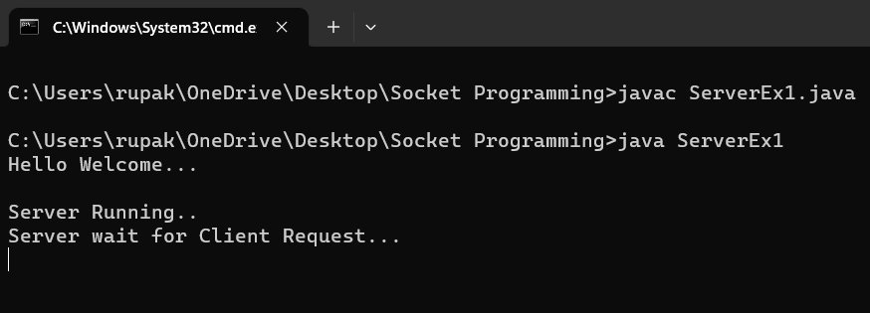

PART 2:

Server Code:

import java.io.*;

import java.net.*;

import java.lang.*;

public class ServerEx1

{

public static void main(String q[]) throws IOException

{

System.out.println("Hello Welcome...");

ServerSocket ss=new ServerSocket(8001);

System.out.println("\nServer Running..");

System.out.println("Server wait for Client Request...");

Socket cs=ss.accept();

DataInputStream in=new DataInputStream(cs.getInputStream());

String msg=in.readUTF();

System.out.println("\n"+msg+"\n");

}

}

Client Code:

import java.io.*;

import java.net.*;

public class ClientEx1

{

public static void main(String q[]) throws IOException

{

Socket sc=new Socket("localhost",8001);

DataOutputStream out=new DataOutputStream(sc.getOutputStream());

String id="Hello";

out.writeUTF(id);

}

}

Server Output:

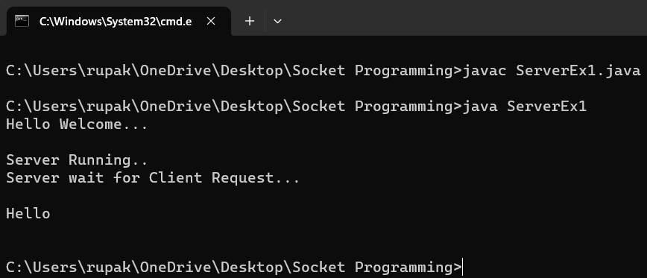

PART 3

Server Code:

import java.io.*;

import java.net.*;

import java.lang.*;

public class ServerEx1

{

public static void main(String q[]) throws IOException

{

System.out.println("Hello Welcome...");

ServerSocket ss=new ServerSocket(8001);

System.out.println("\nServer Running..");

System.out.println("Server wait for Client Request...");

Socket cs=ss.accept();

DataInputStream in=new DataInputStream(cs.getInputStream());

String msg=in.readUTF();

int count=msg.length();

System.out.println("\n"+msg+"\n");

System.out.println("Number of characters in the String "+msg+" are: "+count);

}

}

Client Code:

import java.io.*;

import java.net.*;

public class ClientEx1

{

public static void main(String q[]) throws IOException

{

Socket sc=new Socket("localhost",8001);

DataOutputStream out=new DataOutputStream(sc.getOutputStream());

String id="Hello";

out.writeUTF(id);

}

}

Server Output:

